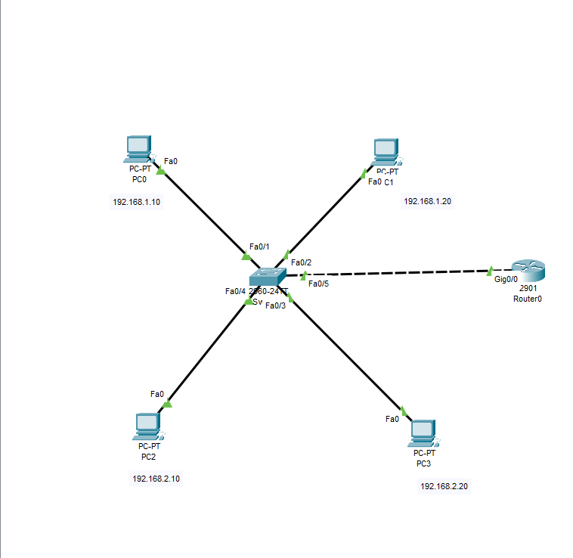

Switch commands

Switch>enable

Switch#config

Configuring from terminal, memory, or network [terminal]? y

?Must be "terminal", "memory" or "network"

Switch#conf

Configuring from terminal, memory, or network [terminal]?

Enter configuration commands, one per line. End with CNTL/Z.

Switch(config)#vlan 10

Switch(config-vlan)#name student

Switch(config-vlan)#exit

Switch(config)#vlan 20

Switch(config-vlan)#name staff

Switch(config-vlan)#exit

Switch(config)#int fa0/1

Switch(config-if)#switchport mode access

Switch(config-if)#switchport access vlan 10

Switch(config-if)#exit

Switch(config)#int fa0/2

Switch(config-if)#switchport mode access

Switch(config-if)#switchport access vlan 20

Switch(config-if)#exit exit

^

% Invalid input detected at '^' marker.

Switch(config-if)#exit

Switch(config)#int fa0/4

Switch(config-if)#switchport mode access

Switch(config-if)#switchport access vlan 10

Switch(config-if)#exit

Switch(config)#int fa0/3

Switch(config-if)#switchport mode access

Switch(config-if)#switchport access vlan 20

Switch(config-if)#exit

Switch(config)#int fa0/5

Switch(config-if)#switchport mode trunk

Switch(config-if)#do write

Building configuration...

[OK]

Switch(config-if)#

%LINK-5-CHANGED: Interface FastEthernet0/5, changed state to up

%LINEPROTO-5-UPDOWN: Line protocol on Interface FastEthernet0/5, changed state to up

Switch#

Router Code

Router>enable

Router#conf

Configuring from terminal, memory, or network [terminal]?

Enter configuration commands, one per line. End with CNTL/Z.

Router(config)#int g0/0

Router(config-if)#no shutdown

Router(config-if)#

%LINK-5-CHANGED: Interface GigabitEthernet0/0, changed state to up

%LINEPROTO-5-UPDOWN: Line protocol on Interface GigabitEthernet0/0, changed state to up

Router(config-if)#int g0/0.10

Router(config-subif)#

%LINK-5-CHANGED: Interface GigabitEthernet0/0.10, changed state to up

%LINEPROTO-5-UPDOWN: Line protocol on Interface GigabitEthernet0/0.10, changed state to up

Router(config-subif)#encapsulation dot1q 10

Router(config-subif)#ip 192.168.1.1 255.255.255.0

^

% Invalid input detected at '^' marker.

Router(config-subif)#ip add 192.168.1.1 255.255.255.0

Router(config-subif)#exit

Router(config)#int g0/0

Router(config-if)#no shutdown

Router(config-if)#int g0/0.20

Router(config-subif)#

%LINK-5-CHANGED: Interface GigabitEthernet0/0.20, changed state to up

%LINEPROTO-5-UPDOWN: Line protocol on Interface GigabitEthernet0/0.20, changed state to up

Router(config-subif)#encapsulation dot1q 20

Router(config-subif)#ip add 192.168.2.1 255.255.255.0

Router(config-subif)#exit

Router(config)#do write

Building configuration...

[OK]

Router(config)#exit

Router#

%SYS-5-CONFIG_I: Configured from console by console